CRYPTO TRADING AUTOMATION
Demo Pipeline Report
TradingView Webhooks + Flask + Binance TESTNET

Student Name | Arshah Lamees

Student ID | 22L-6979

Date | 12 May 2026

1. Introduction
This project shows a cryptocurrency trading system which functions only as a demonstration product. The system connects TradingView alerts, generated by a Pine Script strategy, to a Python Flask webhook server. The Flask server uses alerts to execute spot market trades on the Binance TESTNET while it stores all trading outcomes in local storage.
The pipeline exists as an educational tool for research purposes. The Binance TESTNET environment operates throughout the project because it prevents any actual transactions from taking place. This method enables developers to create and assess event-driven trading systems without exposing any financial hazards. The testnet system functions like the actual Binance Spot API but uses virtual money instead of real funds.

2. Trading Strategy Overview
The strategy is a classic trend-following system enhanced with momentum confirmation. It uses three indicators:

- EMA(9) — Fast EMA: Responds quickly to recent price movements.
- EMA(21) — Slow EMA: Reflects the broader medium-term trend.
- RSI(14): Measures momentum to confirm whether a trend has strength.

Signal Rules
- Buy rule: EMA(9) crosses above EMA(21) AND RSI > 50. This indicates a bullish crossover supported by positive momentum.
- Sell rule: EMA(9) crosses below EMA(21) AND RSI < 50. This indicates a bearish crossover supported by weakening momentum.

Rationale
Using two EMAs filters out short-term noise while the RSI filter avoids entering trades when momentum does not support the crossover direction. This combination reduces false signals compared to using EMA crosses alone.

Limitations
- EMA indicators lag behind price; signals may arrive after the optimal entry point.
- In sideways or ranging markets, frequent EMA crossovers can generate many false signals.
- RSI alone does not confirm trend direction; it only confirms momentum strength.
- No stop-loss or take-profit logic is included in this demo implementation.

3. Pine Script Explanation
The Pine Script file (pine_script/tradingview_strategy.txt) implements the EMA Cross + RSI Webhook strategy directly in TradingView's Pine Script v5 environment.

Indicator Computation
- emaFast = ta.ema(close, fastLen) — computes the 9-period EMA on closing prices.
- emaSlow = ta.ema(close, slowLen) — computes the 21-period EMA on closing prices.
- rsi = ta.rsi(close, rsiLen) — computes RSI over 14 periods.

Signal Formation
- bullX = ta.crossover(emaFast, emaSlow) — detects upward EMA crossovers.
- bearX = ta.crossunder(emaFast, emaSlow) — detects downward EMA crossovers.
- buySignal = bullX and rsi > rsiBuy — final buy trigger.
- sellSignal = bearX and rsi < rsiSell — final sell trigger.

Strategy Tester & Labels
The script uses strategy.entry("Long", strategy.long) for buy signals and strategy.close("Long") for sell signals. Visual labels (plotshape) mark BUY and SELL points directly on the chart, making signal review straightforward in the Strategy Tester.

Alert Conditions & JSON Payload
- alertcondition(buySignal, title="Webhook BUY (JSON)", message=buyJson) — registers the buy alert.
- alertcondition(sellSignal, title="Webhook SELL (JSON)", message=sellJson) — registers the sell alert.

The JSON messages use TradingView placeholders:
{"signal":"buy","symbol":"{{ticker}}","price":"{{close}}"}
The {{ticker}} and {{close}} placeholders are substituted at alert-fire time, ensuring the Flask server receives accurate symbol and price data.

Screenshot: TradingView Chart with Pine Editor
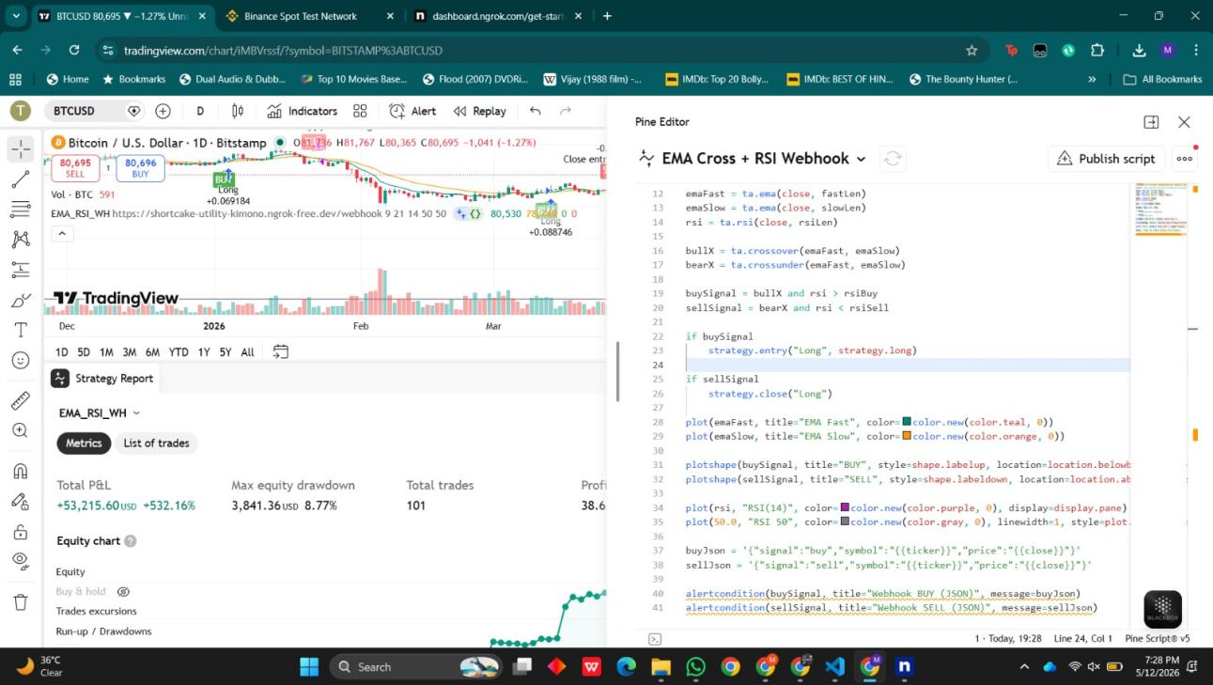
Figure 1: TradingView chart showing EMA Cross + RSI strategy with Pine Script editor and Strategy Report

4. Webhook Workflow
The end-to-end flow from signal generation to order placement proceeds as follows:

- TradingView fires an alert when buySignal or sellSignal conditions are met on a new candle close.
- TradingView sends an HTTP POST request to the configured public webhook URL with the JSON payload.
- The ngrok tunnel receives the HTTPS request and forwards it to Flask running on localhost:5000.
- Flask receives the JSON payload at the /webhook route.
- The server validates required fields (signal, symbol, price).
- The exchange module is called to place a demo market order on Binance Testnet.
- Flask returns a JSON response confirming the order status (success or error).
- The result is appended to trades.csv and logged to logs/webhook.log.

Screenshot: ngrok Tunnel Active
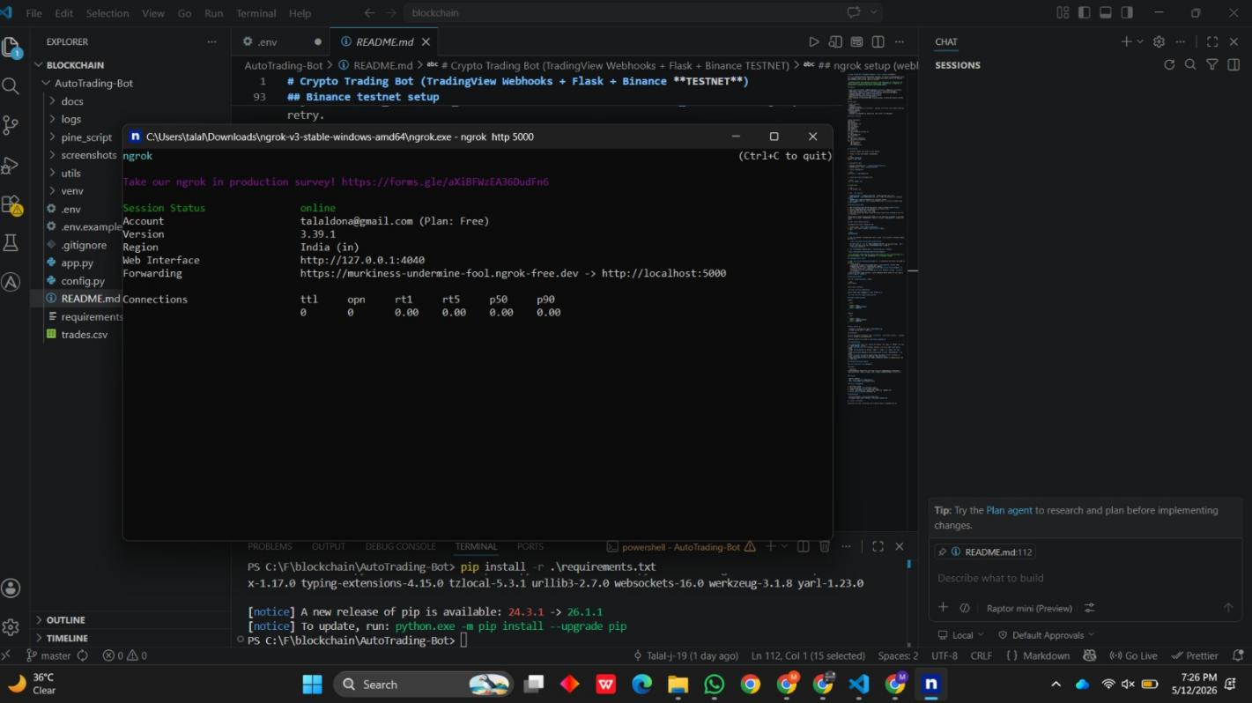
Figure 2: ngrok tunnel forwarding HTTPS traffic to Flask on localhost:5000, with VS Code project structure visible

5. Python Backend Explanation
The backend is structured into focused modules, each with a single responsibility:

- app.py: Main Flask application. Defines the /webhook POST route, handles request parsing, logs incoming payloads, and returns structured JSON responses. Includes error handling for malformed requests (HTTP 400) and server errors (HTTP 500).

- config.py: The script config.py uses python-.env to load environment variables from the .env file. The system enforces TESTNET=True as a safety measure while it supplies Binance API credentials to all other modules..

- utils/validators.py: The script in utils/validators.py performs validation on incoming JSON data. The system verifies that both signal and symbol fields exist in incoming data while checking that signal value matches either buy or sell as allowed options. The system generates error messages that explain the reasons for payloads being invalid.

- utils/logger.py: The system establishes a file handler that rotates its log file to record all events into logs/webhook.log. The system controls log file size to prevent unlimited growth which would occur if users tested the system multiple times.

- utils/exchange.py: The system establishes a python-binance Spot client through the python-binance library which operates in testnet mode. The function execute_trade() executes market orders to buy or sell assets at specified amounts for particular assets. The system records all trading results in trades.csv while it logs the execution results.

HTTP Status Code Usage
- 200 OK — order placed successfully.
- 400 Bad Request — invalid JSON structure or missing/invalid fields.
- 500 Internal Server Error — Binance API failure or unexpected exception.

Screenshot: Flask Console and Successful Testnet Trade
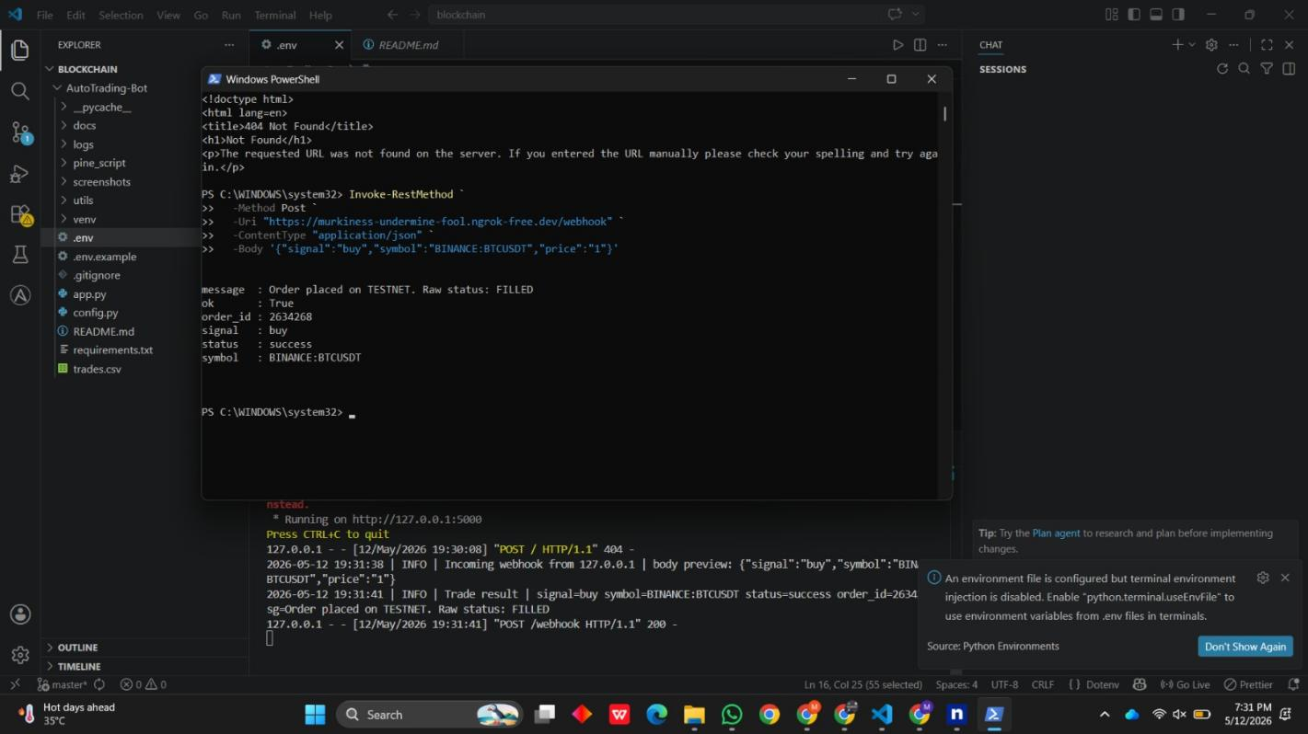
Figure 3: PowerShell sending a test webhook POST; Flask console showing successful TESTNET order (FILLED, order_id 2634268)

6. Binance Testnet Integration

Obtaining Testnet API Keys
Test API keys are generated at https://testnet.binance.vision/ after logging in with a GitHub account. The HMAC-SHA-256 API Key and Secret Key are displayed once and must be saved immediately and they cannot be retrieved again after leaving the page.

Screenshot: Testnet API Key Generation
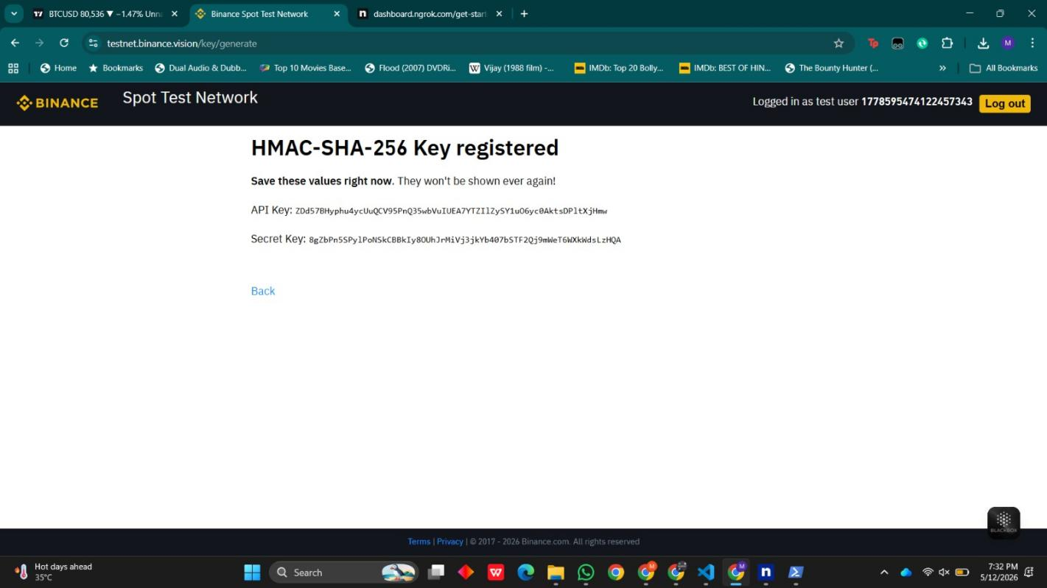
Figure 4: Binance Spot Test Network showing newly generated HMAC-SHA-256 API Key and Secret Key

7. System Architecture

Data Flow Overview
The following diagram illustrates the end-to-end data path from TradingView signal generation through to local logging:

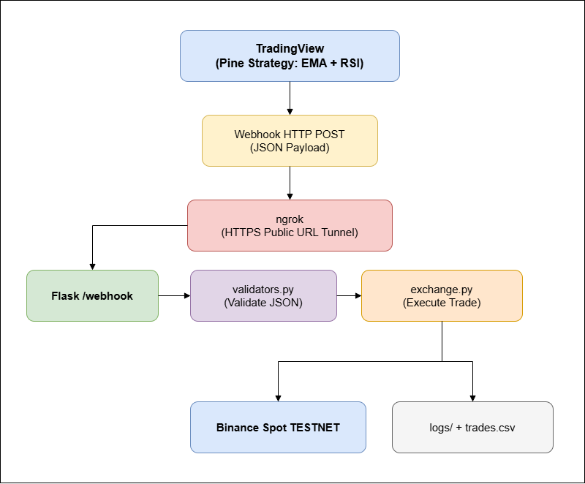

8. Challenges Faced
The development process faced various challenges such as:
- Handling the dynamic nature of ngrok URLs.
- Correctly formatting the TradingView JSON message to match the Flask validator.
- Managing symbol normalization for the Binance API.

9. Conclusion
This project successfully delivered a functional, demo-only crypto trading automation pipeline. TradingView Pine Script generates EMA + RSI cross signals, fires JSON webhook alerts, and transmits them to a Flask backend via an ngrok tunnel. The backend validates payloads, calls the Binance Spot TESTNET API through python-binance, and persistently logs every trade to both a CSV file and a rotating log file.

10. Future Improvements
- Replace `trades.csv` with a database such as SQLite or PostgreSQL for improved data management and auditing.
- Add webhook signature verification using a shared secret to prevent unauthorised requests.
- The system needs idempotency checks because webhooks require trading operations to be executed only once.
- The system needs rate limiting and retry mechanisms with exponential backoff because it has to manage temporary API failures.
- The system needs to fetch trading pair metadata from Binance because current implementation requires hardcoded values.
- The development team needs to create a paper trading simulator which allows testing of strategies without using Binance Testnet.
- The team needs to use Docker containerization to create a Flask application because it simplifies both deployment and system portability.
- The web dashboard will provide users with capabilities to monitor their trade history and evaluate their equity performance while receiving real-time trading signals.

